# Drivers Digital Logbook Design Folio

By Owen Bartley, 12P

### Design

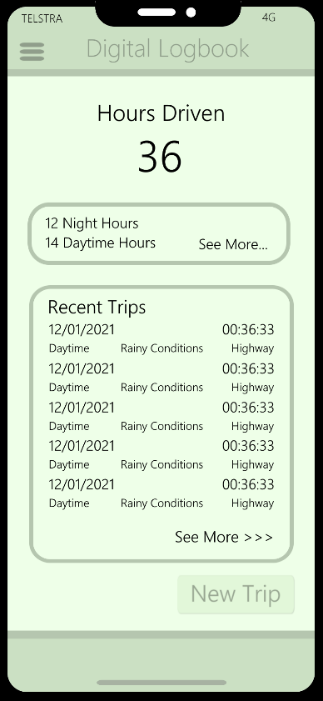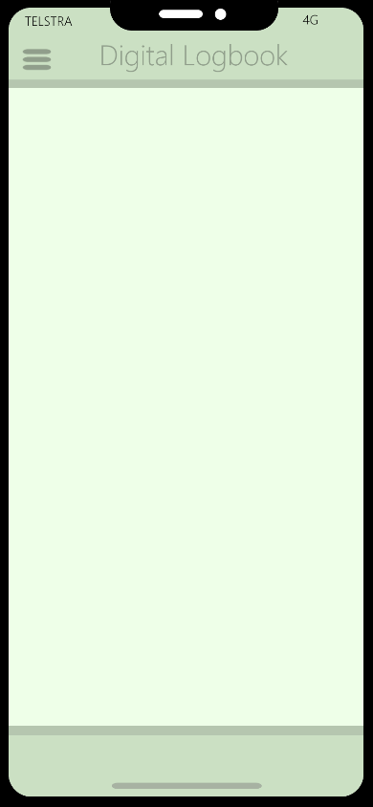

Necessary information and data output areas added and grouped to improve usability. See more button where user can view more existing date. New trip button at the bottom where user can enter new data.

Design of a blank iPhone screen to be used as a template for the base of the digital app design.

Basic layout and colours added to iPhone template. This acts as a template for Design #1

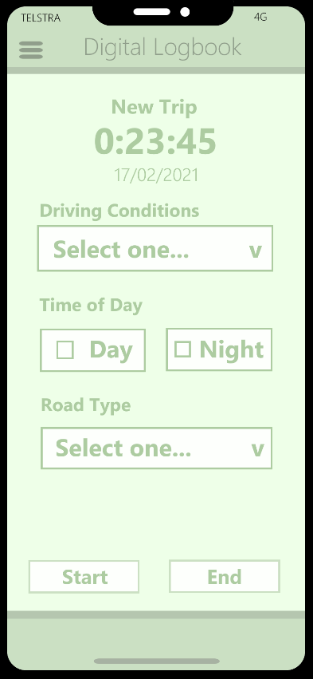

New trip input screen shows various data entry points and a Start/End time feature, for the recording of trip length. Upon pressing end, the data will be validated, and timer will be stopped, storing the data in an array.

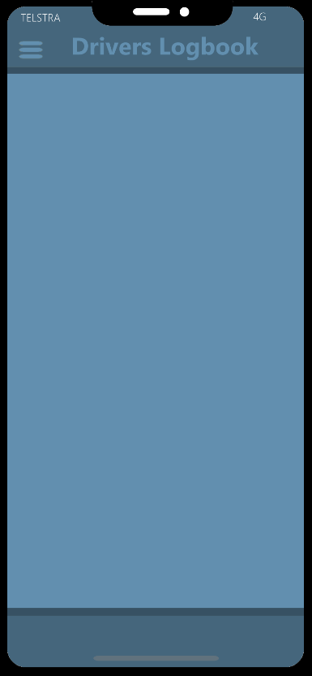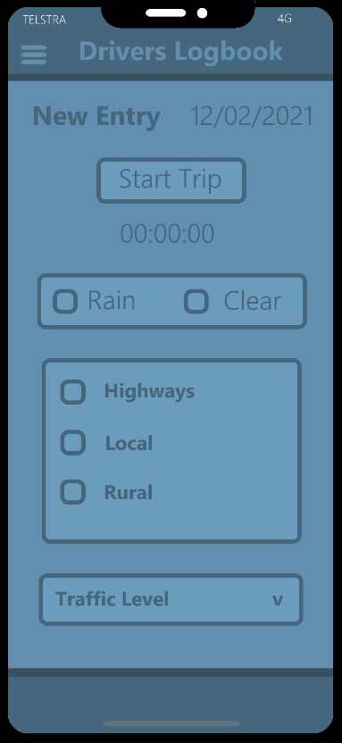

Using new colour design, A more simplified layout is shown here, displaying the data entry screen. Once pressed, the ‘Start Trip’ button changes to an ‘End Trip’ button. This design uses checkboxes over drop down boxes in order to allow multiple inputs to be selected.

Basic layout but with different colours & bolder font choices. Title and layout remains the same as a basic template.

### Evaluation

When creating both designs, I wanted to achieve a simplistic pastel look and feel to the application. In the first design, I opted for a light green feel, with a black font. The second design incorporates a dark blue colour, with a bold dark font to contrast from the lighter background. For my final design, I have decided to opt for design B. I have chosen this design due to the simplified layout and cleaner design choices. The use of less buttons and checkboxes allows multiple variables to be selected and ease of useability for the users. Not only do both design A & B follow the basic requirements of the software, but also create a visually appealing application interface for the audience to interact with. The modernity of this application is intended to showcase an effective and simplistic layout to increase the attractiveness of the software. The UI layouts include the necessary data entry points, being weather, road type, traffic level and trip duration. The use of a start/stop trip button is efficient in both stopping the trip and validating the input. If the stop trip button is pressed and some of the input fields are empty, an error message will display. The home screen of the application shows a summary of the recent trips, with a button to view a more detailed showcase of data. This design meets the solution requirements of the project having all of the necessary input and output areas in a simplistic look.

The efficiency and effectiveness of the solution will require the design to follow the following set of design criteria. Layout and visibility will contribute to the ease of use of the application, as the use of group boxes and check boxes create a usable application. Both designs of the program will be able to cater towards the functional requirements listed in the SRS, and also satisfy the constraints listed in the SRS. In relation to scalability, due to the modern-day storage capacity on mobile phones, data storage is not a problem that either design faces. The use of a ‘see more’ button allows the user to see all data necessary. Due to the simplified number of features in design B, this design would be slightly quicker to develop, but there is not much of a difference in terms of time for the two designs. There will be no budget for this project, as there is not a need for one. The project will include internal documentation throughout the development process in relation to the design features, to create easier maintenance in the future. No training will be needed to learn or use the interface. Both designs are compatible with the latest version of iOS running on iPhones.

### Object Description

|  |  |  |
| --- | --- | --- |
| Function Name | Function Description | Function Event |
| mainForm | Home page of application | None |
| inputForm | Input page of application | None |
| summaryForm | Summary page of application | None |
| ChkRain | Check box of rain weather type | None |
| ChkClear | Check box of clear weather type | None |
| BtnStartStop | Button to start and stop the trip | On Click |
| ChkHighway | Check box of highway road type | None |
| ChkLocal | Check box of local road type | None |
| ChkRural | Check box of rural road type | None |
| LblDuration | Label showing current trip duration | Show |
| LblDate | Label showing date | Show |
| CmbBxTraffic | Combo box of different traffic levels | None |
| LblTotalHours | Total hours driven | Show |
| timeOfDay | Check time of day (day/night) | None |
| LblDayTotal | Total of day hours | Show |
| LblNightTotal | Total of night hours | Show |
| LblRecent1 | Shows most recent trip | Show |
| LblRecent2 | Shows second most recent trip | Show |
| LblRecent3 | Shows third most recent trip | Show |
| BtnSeeMore | Button to show detailed data on all trips | On Click |
| BtnNewTrip | Button to go to input window for a new trip | On Click |

### Pseudocode

**BEGIN**

LOAD trips.xml

//XML file structure

<?xml version="1.0"?>

<trips>

<tripid="1001">

<date>20/03/2021</date>

<duration>63</duration>

<weatherRain>True</weatherRain>

<weatherClear>False</weatherClear>

<trafficLight>True</trafficLight>

<trafficMed>False</trafficMed>

<trafficHeavy>True</trafficHeavy>

<roadLocal>True</roadLocal>

<roadRural>False</roadRural>

<roadHighway>False</roadHighway>

</trip>

</trips>

//Record: Trip

Trip{

Int tripID

String date

Int duration

Boolean weatherRain

Boolean weatherClear

Boolean trafficLight

Boolean trafficMed

Boolean trafficHeavy

Boolean roadLocal

Boolean roadRural

Boolean roadHighway

}

**Subroutine CalculateDriveTotals()**

**Begin**

**Repeat**

Read tripID, date, duration, weatherRain, weatherClear, trafficLight, trafficMid, trafficHeavy FROM trips.xml

Trip.tripID 🡨 tripID

Trip.date 🡨 date

Trip.duration 🡨 duration

Trip.rain 🡨 weatherRain

Trip.clear 🡨 weatherClear

Trip.light 🡨 trafficLight

Trip.medium 🡨 trafficMed

Trip.heavy 🡨 trafficHeavy

Trip.highway 🡨 roadHighway

Trip.rural 🡨 roadRural

Trip.local 🡨 roadLocal

Trips[Index] 🡨 Trip

Index 🡨 Index + 1

**Until EOF**

**End**

//Variables to hold running totals

**Foreach** trip in trips **Do**

//Calculate total trip data

**End Foreach**

//Display

**New Trip**

Event Start_OnClick()

Begin

startTime 🡨 Now

End

**End Trip**

Event End_OnClick()

Begin

Input //All data from GUI

Write, duration, weatherClear, weatherRainy, trafficMid, trafficLight, trafficHeavy, roadHighway, roadLocal, roadRural To Trips XML

End

**See More**

Event SeeMore_OnClick()

Begin

Input //All data from XML

Display duration, weatherClear, weatherRainy, trafficMid, trafficLight, trafficHeavy, roadHighway, roadLocal, roadRural in labelTotals

End

**End**

### Data Dictionary

|  |  |  |  |
| --- | --- | --- | --- |
| Variable Name | Variable Type | Usage | Comment |
| date | Date/Time String | 00/00/00 | Date the trip was created |
| duration | Date/Time Integer | 999 | How long the trip went for in minutes |
| tripID | Integer | 9999 | Unique ID for the trip |
| weatherRain | Boolean | True/False | Rainy weather checkbox |
| weatherClear | Boolean | True/False | Clear weather checkbox |
| trafficLight | Boolean | True/False | Light traffic checkbox |
| trafficMed | Boolean | True/False | Medium traffic checkbox |
| trafficHeavy | Boolean | True/False | Heavy traffic checkbox |
| roadHighway | Boolean | True/False | Highway road checkbox |
| roadRural | Boolean | True/False | Rural road checkbox |
| roadLocal | Boolean | True/False | Local road checkbox |
| Trip | Record | -- | A record to store all of the trips |
| Trips[] | Array | -- | An array of a certain trip |